University of California San Diego Dr. Christine Payne (she/her)

Department of Sociology [**capayne@ucsd.edu**](mailto:capayne@ucsd.edu)

Spring 2025

**MWF 5:00-5:50 pm PST**

**Mondays & Wednesdays: In-Person** **Instruction** **in** **CENTR 220**

**Fridays:** **Synchronous Online Instruction\*\*\***

**Friday Synchronous Zoom Link**: [**https://ucsd.zoom.us/j/99946700641**](https://ucsd.zoom.us/j/99946700641)

**\*\*\*Exceptions:**

***In-Person* Friday April 4th (Week 1) & Friday June 6th (Week 10)**

***Asynchronous* Friday May 9th**

**Professor Payne’s Weekly Online Office Hours**: **Tuesdays/Thursdays** **11 am – 12 pm PST**

**Professor Payne’s Office Hours Link**: [**https://ucsd.zoom.us/j/99946700641**](https://ucsd.zoom.us/j/99946700641)

**1963 March on Washington for Jobs and Freedom

Demonstrators march through the streets. Colorized by Oliver Wistisen.
Original photo by Warren K. Leffler/Library of Congress**

**B**

**SOCI 106 – Comparative Historical Methods**

How does social change happen? Under what conditions do ideas, meanings, values, and actions emerge or take shape? In what ways do ideas, meanings, values, and actions get sedimented, reproduced, modified, transformed, challenged, replaced, or rejected?

What factors or elements are most significant or crucial when attempting to make sense of processes of social change? What might we gain by comparing moments and processes of change to one another? How can historical explanations inform ongoing and future understandings and interventions with respect to social change? What role do various subjects and social actors have in effecting change – and how are they positively or negatively impacted by large-scale social changes? What role do institutions - such as the state, economy, law, religion, education, and science - play vis-à-vis social change? Do institutions enable, inhibit, maintain, or disrupt challenges to the status quo?

What interests and ideologies – be they political, economic, cultural – motivate or impede social changes? What roles do class, gender, race, sexuality, and ethnicity play with respect to social change? When is social change – for better or for worse – successful? Unsuccessful?

Is social change inevitable? Is there a ‘logic’ to social development – does it occur in any patterned fashion? Or is social change sporadic and random? Can change be predicted or anticipated in advance? Or are we left to puzzle it out after the fact?

These are some of the broad questions that a critical sociological approach to comparative historical methods aims to address and which we will be considering. Our overarching motivation is the critical comparative exploration of various historical moments of significant social change. Our central goal is to identify, understand, and hone the use of comparative historical methods in order to position ourselves well for the identification and explanation of historical and ongoing social change.

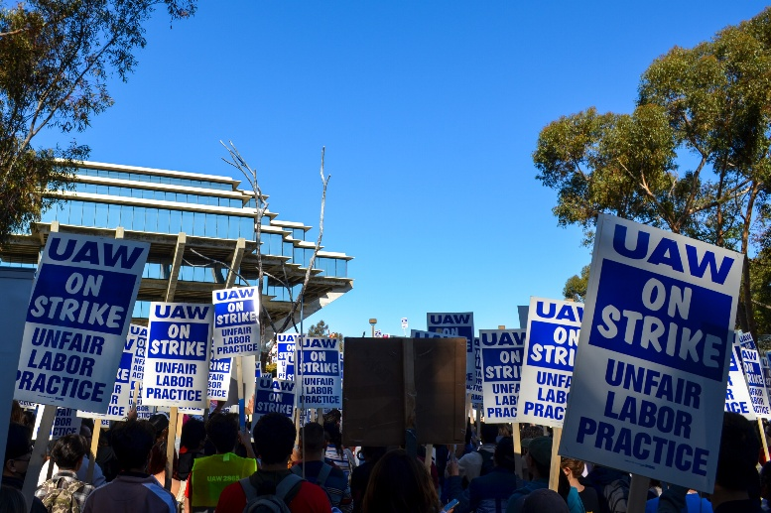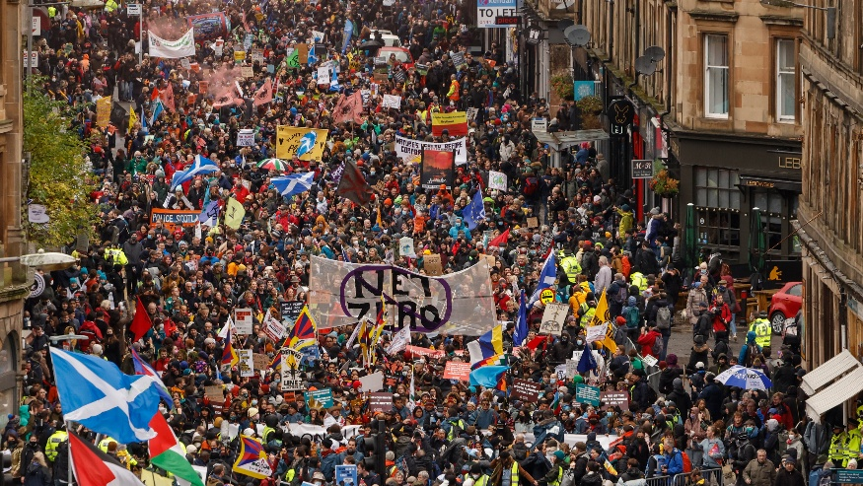

# **Student Learning Objectives**

* **Develop and deploy a critical sociological perspective**; more specifically, understand and apply key sociological concepts – including culture, class, race, sexuality, and gender - as they relate to the practices of comparative historical methods;
* Reflect upon the strengths and weaknesses of **different conceptualizations of history**, particularly as these different conceptualizations relate to the enhancement or diminishment of **describing and explaining patterns of social action**;
* Recognize and reflect upon the **strengths and weaknesses of deductive and inductive forms of reasoning as well as nomothetic and ideographic approaches** to explanation;
* Critically consider the **interdependent relationships between ideological and institutional patterns** as they enable and constrain sociological understandings across time periods and cultural contexts;
* Evaluate the **role of counterfactuals** in relation to questions of comparative and historical explanations;
* Compare the **efficacy and validity of various evidentiary sources, units of analysis, and case comparisons** with respect to correlative and causal reasoning;
* Identify and communicate interesting aspects of, or illuminating **relations between, theoretical concepts and empirical applications**; critique concepts and analyses, evaluating their capabilities and limitations;
* **Craft a comparative historical research proposal with annotated bibliography;**
* **Identify possibilities for theoretical and empirical modification in both one’s own and others’ conceptualizations and deployments of comparative historical methodological practices** with the goal of cultivating more robust tools for sociological description, explanation, and intervention.

# **Email**

Allow 24 hours for a response to email messages Monday-Friday. If you know you have a question or will need to be in touch, please do so sooner than later. If you have questions that require in-depth answers, I may request that we meet during office hours.

# **Office Hours**

**Professor Payne’s Weekly Online Office Hours**: **Tuesdays/Thursdays** **11 am – 12 pm PST**

**Office Hours Link**: [**https://ucsd.zoom.us/j/99946700641**](https://ucsd.zoom.us/j/99946700641)

# **Readings and Lecture Notes**

Weekly course readings and weekly lecture notes are housed in associated weekly folder on course Canvas page under the **‘Files’ tab.**

# **Course Canvas Organization**

* Course Syllabus (**Syllabus**)
* Weekly Readings and Weekly Lecture Notes (**Files**)
* Captured Lectures (**Media Gallery**)
* Assignments #1-4; Final Paper (**Assignments**)
* Friday Synchronous Online Zoom Link (**Announcements**)
* Weekly Office Hours Zoom Link (**Announcements**)
* Grades (**Grades**)

**Canvas will be used to communicate all course-wide announcements.**

**Be sure that you are able to access Canvas for the duration of the course.**

**Check Canvas regularly for any course-wide announcements.**

# **Required Course Materials**

# **Blue Book** – One (1); Any Size Okay

* **Pen/Pencil and Notepaper** for In-Class Reading Quizzes

# **UCSD Library & VPN Login Information**

**(For Documentary Viewings)**

[**https://blink.ucsd.edu/technology/network/connections/off-campus/VPN/**](https://blink.ucsd.edu/technology/network/connections/off-campus/VPN/)

# **Coursework & Grading**

The final course grade for SOCI 106 is calculated out of **1000 points**.

**Details of each graded component will be covered in lecture.**

1. **In-Class Reading Quizzes (20 points x 7 Reflections = 140 points)**

**Two Lowest Scores Dropped**

**Consist of 1-3 short questions on weekly readings.**

**Beginning of Lecture on Mondays Weeks 2-8**

1. **Assignments #1-4 (100 points x 4 Assignments = 400 points)**

**Due Fridays by end of day (11:59 pm PST) Weeks 3, 5, 7, 9**

1. **In-Class Test (160 points)**

**Key concept explanations covering Weeks 1-9.**

**Wednesday June 4th**

1. **Final Paper (300 points)**

**Consists of a 10-12-page preliminary comparative historical research analysis.**

**Due end of day (11:59 pm PST) on Friday June 13th**

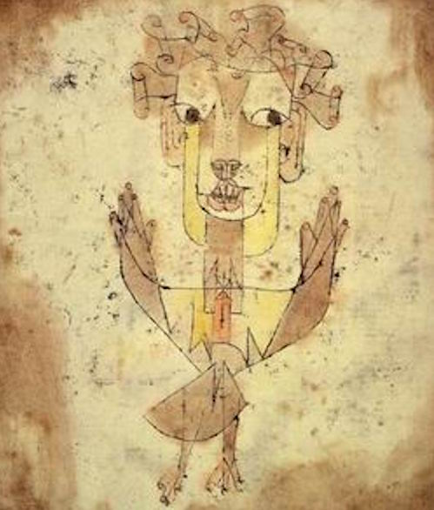

# **Assignment Policies**

* **No Make-Up Reading Reflections – Two Lowest Scores Dropped.**
* **No Unauthorized Make-Ups for In-Class Test.\***
* **Late Assignments Deducted 5% of Total Points Per Day Late.**
* **No Retakes/Resubmissions of Graded Work.**
* **No Work Accepted Past Last Day of Regular Class – Fri. June 6th.**
* **Excepting Clerical Errors, No Grade Adjustments Made After Final Paper Due Date – Friday June 13th.**

**\* Excepting Authorized Accommodations; Emergency.**

**\*Authorized Make-Up Test Must be Completed Within 1 Week.**

# **Course Grading Scale**

100+: A+

100-93: A

92-90: A-

89-88: B+

87-83: B

82-80: B-

79-78: C+

77-73: C

72-70: C-

69-60: D

59 and below: F

# **Respect**

At their best, college courses flourish when everyone involved takes seriously the responsibility to engage course material in a critical manner. Critical engagement is grounded in thoughtful reflection, and such thoughtful reflection may provide opportunities for respectful disagreement. Respectful disagreement often leads to illuminating discussions and further thoughtful engagement for us all.

What I expect and require across all components of our course is a mature and mindful space that refrains from personal attacks and explicit or implied hostility. In the intellectual and ethical interests of us all, I do not tolerate disrespectful or hostile discussion. As we cultivate our learning spaces together, it promotes our intellectual endeavors to harbor these differences and similarities, agreements and disagreements, towards promoting the free exchange of ideas and a space where that is possible.

**Academic Integrity**

All academic work must be done by the individual to whom it is assigned, without unauthorized aid of any kind.

**Avoid even unintentional plagiarism.**

**Cite all direct quotes, all paraphrases.**

**Give full credit to the sources for your ideas and writing.**

**Cite where your major concepts/ideas/arguments are coming from.**

**Use of AI to complete SOCI 106 coursework is a violation of academic integrity.**

**Violations of academic integrity will result in a grade of ‘0’ for the assignment.**

**Violations will also be referred to the college for administrative action**.

**UCSD’s academic integrity information can be viewed here:** [**https://students.ucsd.edu/academics/academic-integrity/index.html**](https://students.ucsd.edu/academics/academic-integrity/index.html)

If you have any questions regarding academic integrity, do not hesitate to reach out at any time.

# **Course Schedule (Subject to Minor Variation as Necessary)**

**Week One – Introduction to Course; Research Proposal Components**

* **Reminder: In-Class Friday April 4th**

**Week Two – Classical Comparative Historical Exemplar**

* *The Manifesto of the Communist Party* - Marx & Engels. Pp. 473-483
* **Reading Quiz #1 Monday April 7th**

**Week Three – Progressive(ish) Theories of Socio-Historical Change**

* *Poor People's Movements: Why They Succeed, How They Fail*. Piven & Cloward.

Ch. 2 - Pp. 41-92

* **Reading Reflection #2 Monday April 14th**
* **Assignment #1 Due Friday April 18th – Introduction & Methods**

**Week Four – Enabling & Constraining States**

* *Poor People's Movements: Why They Succeed, How They Fail*. Piven & Cloward.

Ch. 3 - Pp. 96-175

* **Reading Reflection #3 Monday April 21st**

**Week Five – Disruptions, Demands, & Democrat(ic) Decisions**

* *Poor People's Movements: Why They Succeed, How They Fail.* Piven & Cloward.

Ch. 4 - Pp. 181-258

* **Reading Reflection #4 Monday April 28th**
* **Assignment #2 Due Friday May 2nd – Annotated Bibliography Pt. 1**

**Week Six – Primitive Accumulation: Classes, Crises, & Confrontations**

* *Caliban and the Witch* – Federici. Pp. 21-115
* **Reading Reflection #5 Monday May 5th**
* **Lecture is Asynchronous Friday May 9th** 🡪 **Canvas/‘Media Gallery’ tab)**

**Week Seven – Reproductive Labor: Gendered Subjects, Gendered Strategies**

* *Caliban and the Witch* – Federici. Pp. 133-217
* **Reading Reflection #6 Monday May 12th**
* **Assignment #3 Due Friday May 16th – Annotated Bibliography Pt. 2**

**Week Eight – Constructions of Difference, Conceptions of Development**

* *Medicalizing Blackness* – Hogarth. Pp. 17-77
* **Reading Reflection #7 Monday May 19th**

**Week Nine – Disciplining ‘Difference,’ Directing ‘Development’**

* **Monday May 26th – Memorial Day – No Class.**
* *Medicalizing Blackness* – Hogarth. Pp. 133-186
* **Assignment #4 Due Friday May 30th – Preliminary Findings & Analysis**

**Week Ten – Review; Test; Course Wrap-Up**

* **Monday June 2nd***–* **Test Review**
* **Wednesday June 4th- In-Person Test**
* **Friday June 6th – In-Class Course Review/Wrap-Up**

**Final Paper Due: Friday June 13th (11:59 pm PST)**

# **Bibliography**

***The Manifesto of the Communist Party***

Karl Marx & Friedrich Engels. 1978 [1848]. W.W. Norton.

*The Marx-Engels Reader* 2nd edition (ed. Robert Tucker)

***Poor People's Movements: Why They Succeed, How They Fail***

Frances Fox Piven & Richard A. Cloward. 1979. Vintage Books.

Ch. 2 – “The Unemployed Worker’s Movement;” Ch. 3 – “The Industrial Worker’s Movement;” Ch. 4 – “The Civil Rights Movement.”

***Caliban and the Witch: Women, The Body, & Primitive Accumulation***

Silvia Federici. 2004. Autonomedia.

Introduction; Ch. 1 – “All the World Needs a Jolt;” Ch. 2 – “The Accumulation of Labor and the Degradation of Women;” Ch. 3 – “The Great Caliban;” Ch. 4 – “The Great Witch Hunt in Europe;” Ch. 5 – “Colonization and Christianization.

***Medicalizing Blackness: Making Racial Difference in the Atlantic World. 1780-1840***.

Rana A. Hogarth. 2017. University of North Carolina Press.

Ch. 1 – “Black Immunity and Yellow Fever in the American Atlantic;” Ch. 2 – “An African Corps in a Most Distressed and Sickly Condition: Yellow Fever in the West Indies;” Ch. 5 – “That the Asylum for Deserted Negroes Is Now Complete for Their Reception: Surveillance and Sickness in Jamaica;” Ch. 6 – “For the Acquisition of Practical Knowledge: Genealogies of Medical Exploitation in the South.”

# **Sociology Department**

Main Office SSB 401: <https://sociology.ucsd.edu/>

# **Advising**

<https://sociology.ucsd.edu/undergraduate/advising.html>

# **ACCOMODATIONS AND CAMPUS RESOURCES**

Every learning environment should be accessible to all. If you have a disability and require accommodations for this class, please contact:

**UCSD’s OFFICE FOR STUDENTS WITH DISABILITIES:** [**https://osd.ucsd.edu/**](https://osd.ucsd.edu/)

**RELIGIOUS OBSERVANCES**

Please let me know as soon as possible if, for any religious reasons, you will require an extension on a part of your overall assessments.

**UNIVERSITY ACTIVITES**

Please let me know as soon as possible if, for any university activities, you will require an extension on a part of your overall assessments.

**COUNSELING AND PSYCHOLOGICAL SERVICES**

The Counseling Center (CAPS) offers counseling for personal & career concerns, self-help information, and referrals for additional mental health services. <https://caps.ucsd.edu/make-appointment/appointments.html>

**NATIONAL SUICIDE PREVENTION HOTLINE**: 1-800-273-8255

**STUDENT HEALTH SERVICES**

<https://wellness.ucsd.edu/studenthealth/Pages/default.aspx> (or: [studenthealth@ucsd.edu](mailto:studenthealth@ucsd.edu))

**UCSD BASIC NEEDS CENTER**

<https://basicneeds.ucsd.edu/>

**Writing HUB**

If you need help with writing with this or any class, please contact the UCSD Writing Hub.

<https://writinghub.ucsd.edu/>

**Gender Neutral Bathrooms**

There are gender-neutral restrooms on campus.  A complete list with maps can be found at: <https://maps.ucsd.edu/map/Default.htm?id=1005#!ce/37654?ct/0,18011?mc/32.876073117796686,-117.22527980804445?z/15?lvl/0>

**REPORTING SEXUAL VIOLENCE**

Please know that I, like all UCSD faculty, am mandated to report any allegations of sexual assault involving members of the University community to the campus Title IX office. You do not have to follow up with them if you do not wish to, but it is important that you are aware of your resources as well as rights, such as withdrawing from a class if need be. Review information about your rights, how to pursue a university discipline charge and a criminal charge, and how to report the violence without pursuing any charges at: <https://sos.ucsd.edu/filing-a-report/index.html> or call: 858-534-8298.

**UCSD ESCORT SERVICE**

Call extension 4-WALK or (858) 534-9255 from sunset to 4 a.m. daily. After 1 a.m., police department staff may provide this service. You can arrange a repeating escort so a community service officer (CSO) will meet you at the same place and time, which makes it more convenient to get a late-night escort.

**SEXUAL ASSAULT VICTIM ADVOCATE**

<http://care.ucsd.edu/> or call: 858-534-5793

**INTERNATINAL STUDENTS AND PROGRAMS OFFICE (ISPO)**

<https://ispo.ucsd.edu/>

**TRITON TRANSFER CENTER**

[**https://transferstudents.ucsd.edu/**](https://transferstudents.ucsd.edu/)

**BLACK RESOURCE CENTER**

858-534-0471 <https://brc.ucsd.edu/>

**WOMEN’S CENTER**

858-822-0074  <https://women.ucsd.edu/>

**SAN DIEGO LGBT COMMUNITY CENTER**

3909 Centre St., San Diego, CA 92103

<http://www.thecentersd.org/>

**UNDOCUMENTED STUDENT SERVICES**

858-822-6916 <https://uss.ucsd.edu/> (or: [undoc@ucsd.edu](mailto:undoc@ucsd.edu))

**TRANSGENDER CARE**

 (858) 534-3300 <https://wellness.ucsd.edu/studenthealth/services/Pages/transgender-care.aspx>

**RAZA RESOURCE CENTRO**

858-822-0072 <https://raza.ucsd.edu/>

**INTERTRIBAL RESOURCE CENTER (ITRC)**

858- 822-0048 <https://itrc.ucsd.edu/>

**CROSS CULTURAL CENTER**

858-534-9689  [ccc.ucsd.edu](http://ccc.ucsd.edu/)

**OFFICE OF ACADEMIC SUPPORT & INSTRUCTIONAL SERVICES (OASIS)/EDUCATIONAL OPPORTUNITY PROGRAM (EOP)**

Especially helpful for first generation, non-traditional, and English as a Second Language Students, but of course open to all.

<https://oasis.ucsd.edu/> (or call: 858-534-3760)

**UCSD CAREER CENTER**

The UCSD Career Center can help you assess your interests.

858-534-3751 <https://career.ucsd.edu/> (or: [careercenter@ucsd.edu](mailto:careercenter@ucsd.edu))

**WELL BEING – “The Zone”**

<https://students.ucsd.edu/well-being/index.html>

# **Cheating and Plagiarism**

Cheating and plagiarism are serious offenses. You are plagiarizing or cheating if you:

* For written work, copy anything from a book, article, website, **or AI generator** and add or paste it into your paper without using quotation marks and/or without providing the full reference for the quotation, including page number
* For written work, summarize / paraphrase in your own words ideas you got from a book, article, or the web without providing the reference for the source
* Use academic visuals obtained from a book, article, or website without providing a reference for the visual
* Recycle a paper you wrote for another class
* Turn in the same (or a very similar paper) for two classes
* Purchase or otherwise obtain a paper and turn it in as your own work
* Copy the work of a classmate

**Consequences of cheating and plagiarism**

Consequences are at the instructor’s and the administration’s discretion. Instructors are mandated by the UCSD system to report the offense to the administration. Consequences may include any of the following: warning; failing the assignment; failing the class; probation; suspension; expulsion.