University of California San Diego Dr. Christine Payne (she/her)
Department of Sociology capayne@ucsd.edu
Winter 2026
T/Th 8-9:20 am PST

Tuesdays In-Person Instruction in Warren Lecture Hall (WLH) 2204

Thursdays: Asynchronous Online Instruction*

*Exceptions:

In-Person Thursday January 8th (Week 1)
In-Person Thursday March 12th (Week 10)

Office Hours: TuTh 11:30 am – 12:30 pm
Tuesdays – Social Sciences Building #418
Thursdays - https://ucsd.zoom.us/j/92221546959

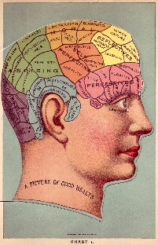

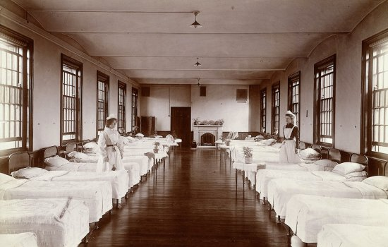

SOCI 136E – Sociology of Mental Illness: A Historical Approach

What characterizes mental illness? What roles have social, cultural, political, and economic contexts played in relation to mental illness - and mental health more generally? How have changes in social contexts and conditions affected the historical identification, understanding, and treatment of mental illness? How, and on what basis, do facts about mental ‘normalcy’ and ‘abnormality’ emerge? What diagnostic classifications and categorization schema have been used to distinguish those deemed ‘sane’ from those identified as ‘mad’? What significance have gender, race, sexuality, and class played in relation to mental illness? Where does legitimate expertise about mental illness reside? On what basis? To what ends?

More broadly: how does medical knowledge and practice relate to social institutions and structures? What role do politics and ethics play in the construction, reproduction, and transformation of knowledge and practices related to individual and collective wellbeing? These are some of the broad questions that a critical historical and sociological approach to mental illness aims to address and which we will be analyzing together.

Student Learning Objectives

Upon satisfactory completion of this course, students will be able to:

- Develop and deploy a critical sociological perspective; more specifically, understand and apply major critical sociological concepts – including class, race, gender, and sexuality - as they relate to the historical experience of mental illness;

- Identify and elaborate upon the significance of social, cultural, political, and economic contexts in relation to historical changes in understandings of mental illness;

- Analyze the historical relationships between social values – including order, morality, productivity, profitability – and diagnoses and treatments of mental illness.

- Demonstrate the historical and ongoing significance of biopower/biopolitical practices in relation to self, health, and society;

- Compare and contrast biological reductionist and social constructionist accounts of mental illness; more broadly, analyze meanings and dynamics between naturalistic and social accounts to health and medicine;

- Reflect upon the distinctions and dynamics at play between care and control in the history of mental illness;

- Locate and evaluate competing claims to socially legitimate expertise in relation to mental health;

- Detect and reflect upon the significance of dualistic diagnostic designations including ‘normal’ vs. ‘abnormal,’ healthy vs. ill, expert vs. non-expert, fact vs. value;

- Identify and communicate interesting aspects of, or illuminating relations between, theoretical concepts and empirical applications;

- Critique concepts and analyses, evaluating their capabilities and limitations;

- Compose analytic essays with organized, well-supported arguments;

- Identify potential interventions or transformations aimed at addressing issues of human freedom, happiness, and health.

Email
Allow 48 hours for a response to email messages Monday-Friday. If you know you have a question or will need to be in touch, please do so sooner than later. If you have questions that require in-depth answers, I may request that we meet during office hours or by appointment.

Required Course Materials

Blue Books – Three (3); Any Size Okay
- Pen/Pencil and Notepaper for In-Class Reading Quizzes

Readings and Lecture Notes
Weekly course readings and weekly lecture notes are housed in associated weekly folders on course Canvas page under the ‘Files’ tab.

UCSD Library & VPN Login Information
For Documentary Viewings
https://blink.ucsd.edu/technology/network/connections/off-campus/VPN/

Course Canvas Organization

- Course Syllabus (Syllabus)
- Weekly Readings and Weekly Lecture Notes (Files)
- Thursday Asynchronous Lectures Weeks 2-9 (Media Gallery)
- Generics/Rubrics for Midterms & Final Exam (Assignments)
- Thursday Hours Zoom Link (Announcements)
- Grades (Grades)

Canvas will be used to communicate all course-wide announcements.
Check Canvas regularly for any course-wide announcements.

Coursework & Grading

The final course grade for SOCI 136e is calculated out of 1000 points.

- In-Class Reading Quizzes (15 points x 6 Quizzes = 90 points)
Two Lowest Scores Dropped at End of Term
Consist of 1-3 short questions on weekly readings.
Tuesday of Weeks 2, 3, 4, 6, 7, 8

- In-Class Midterm 1 (300 points)
One essay covering weeks 1-4
Tuesday February 3rd

- In-Class Midterm 2 (300 points)
One essay covering weeks 5-8
Tuesday March 3rd

- In-Class Final Exam (310 points)
Comprehensive. Two Parts.
Six key concept analyses
One essay
Thursday March 19th 8–11 am PST

Assignment Policies

- No Make-Up Reading Quizzes – Two Lowest Scores Dropped.

- No Unauthorized Make-Ups for In-Class Midterms. **

- No Make-Up/Reschedules of Final Exam. ** No Early Final Exams.

- No Retakes/Revisions of Graded Work.

- Excepting Clerical Errors, No Grade Adjustments Occur After Final Exam – Thursday March 19th.

** Excepting Authorized Accommodations; Emergency.

**Authorized Make-Up Midterms Must be Completed Within 1 Week.

Course Grading Scale

98 and above: A+
100-93: A
92-90: A-
89-88: B+
87-83: B
82-80: B-
79-78: C+
77-73: C
72-70: C-
69-60: D
59 and below: F
59 and below: F

Respect

At their best, college courses flourish when everyone involved takes seriously the responsibility to engage course material in a critical manner. Critical engagement is grounded in thoughtful reflection, and such thoughtful reflection may provide opportunities for respectful disagreement. Respectful disagreement often leads to illuminating discussions and further thoughtful engagement for us all.

What I expect and require across all components of our course is a mature and mindful space that refrains from personal attacks and explicit or implied hostility. In the intellectual and ethical interests of us all, I do not tolerate disrespectful or hostile discussion. As we cultivate our learning spaces together, it promotes our intellectual endeavors to harbor these differences and similarities, agreements and disagreements, towards promoting the free exchange of ideas and a space where that is possible.

Academic Integrity
All academic work must be done by the individual to whom it is assigned, without unauthorized aid of any kind.

Avoid even unintentional plagiarism.
Cite all direct quotes, all paraphrases.
Give full credit to the sources for your ideas and writing.
Cite where your major concepts/ideas/arguments come from.

Use of AI to complete SOCI 136E coursework is a violation of academic integrity.
Violations of academic integrity will result in a grade of ‘0’ for the assignment.
Violations will also be referred to the college for administrative action.

UCSD’s academic integrity information can be viewed here: https://students.ucsd.edu/academics/academic-integrity/index.html

If you have any questions regarding academic integrity, do not hesitate to reach out at any time.

Course Content & Schedule (Subject to Minor Variations as Needed)

Complete Readings Prior To Lecture

Page Numbers Refer to Pages In Texts – not the page numbers across tops of pdfs.

Full Bibliography Available at End of Syllabus

Week One
Introduction to Course; Mental Health in / as Social

- Tues.

Porter – Madness: A Brief History pp. 10-88

- Thurs.

Foucault - Madness and Civilization - Ch. 2 The Great Confinement pp. 38-64

Conrad & Barker – The Social Construction of Illness: Key Insights and Policy Implications pp. 67-79

Week Two
‘Madness’: Cultural Contexts; Contingent (?) Conditions

Reading Quiz #1 Tuesday January 13th (Kroll & Bachrach)

- Tues.

Kroll & Bachrach - Sin and Mental Illness in the Middle Ages pp. 507-14

View: Mysteries of Mental Illness Part 1: Evil or Illness

- Thurs.

Foucault - Madness and Civilization - Ch. 9 The Birth of the Asylum pp. 241-278

Gonaver – The Peculiar Institution and the Making of Modern Psychiatry
Ch. 3 Servants, Obey Your Masters pp. 82-111

Week Three
Psychoanalysis: Happiness vs. (?) Society

Reading Quiz #2 Tuesday January 20th (Freud)

- Tues & Thurs.

Freud - Civilization and its Discontents

Ch. 3, 5, 7, 8
Please Note: May Need to Download Freud Text From Canvas

Week Four
Expertise & Embodiment: Who Knows?

Reading Quiz #3 Tuesday January 27th (Ehrenreich & English)

- Tues.
Ehrenreich and English - Complaints and Disorders pp. 13-44

Briggs - The Race of Hysteria: "Overcivilization" and the "Savage" Woman in Late Nineteenth-Century Obstetrics and Gynecology pp. 246-273

- Thurs.
Gonaver – The Peculiar Institution and the Making of Modern Psychiatry
Ch. 4 Now She is Choked pp. 112-144

Peterson – A Mad People’s History of Madness
pp. 77-91; 116-129; 246-255; 313-326

Week Five
Midterm #1; Methodological Interlude

In-Class Midterm #1 Tuesday February 3rd

- Thurs.

Gilman – The Yellow Wallpaper pp. 11-34

Peterson – A Mad People’s History of Madness
pp. 8-18; 151-160; 177-186; 215-228; 274-283

Week Six
Health, Hygiene, & Hierarchy
Reading Quiz #4 Tuesday February 10th (Rotzoll et al.)

- Tues.

Bridges – The Mental Hygiene Movement pp. 1-8

Rotzoll et al. – The First National Socialist Extermination Crime: The T4 Program and Its First Victims pp. 17-29

Holocaust Encyclopedia - Euthanasia Program and Aktion T4
https://encyclopedia.ushmm.org/content/en/article/euthanasia-program

- Thurs.

Black – War Against the Weak
Ch. 5 Legitimizing Raceology pp. 63-85

Gonaver – The Peculiar Institution and the Making of Modern Psychiatry
Ch. 6 Not a Human Being pp. 173-193

View: Mysteries of Mental Illness Part 2: Who’s Normal?

Week Seven
Care or (?) Control

Reading Quiz #5 Tuesday February 17th (Conrad)

- Tues.

Conrad - Medicalization and Social Control pp. 209-232
Lewontin – Not in Our Genes
Ch. 8 Schizophrenia: The Clash of Determinisms pp. 197-231

Drescher – Queer Diagnoses pp. 427-460

- Thurs

Szasz – The Myth of Mental Illness pp. 113-118

Fountoulakis – Anti-Psychiatry pp. 523-534

View: Mysteries of Mental Illness Part 3: The Rise and Fall of the Asylum

Week Eight
Freud, Fanon, and Feminism: Family Feuds

Reading Quiz #6 Tuesday February 24th (Fanon)

- Tues.

Fanon - Black Skin, White Masks

Ch. 5 The Lived Experience of the Black Man pp. 82-108
Ch. 6 The Black Man and Psychopathology: pp. 109-162

- Thurs.

Firestone – The Dialectic of Sex

Ch. 3 Freudianism: The Misguided Feminism pp. 41-71
Week Nine
Midterm #2; Mid-Century Material(ism) and Mental Health

In-Class Midterm #2 Tuesday March 3rd

- Thurs.
Marcuse – Eros and Civilization
Ch. 4 The Dialectics of Civilization pp. 78-105
Ch. 5 Philosophical Interlude pp. 106-126

Week Ten
Mental Health in / as Social Redux

- Tues.

Final Exam Walk-Through/Review

Esposito and Perez – Neoliberalism and the Commodification of Mental Health pp. 414-422

View: Mysteries of Mental Illness Part 4: New Frontiers

- Thurs.

Toth – RFK Jr’s Plan to Dismantle Support for Americans with Autism

Peterson – A Mad People’s History of Madness pp. 336-338

In-Person Final Exam
Thursday March 19th 8-11 am PST

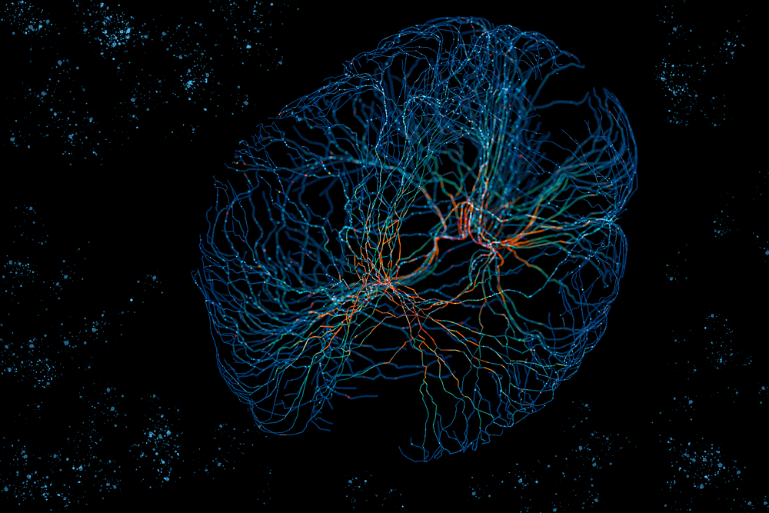

Sociology Department
Main Office SSB 401: https://sociology.ucsd.edu/

Advising
https://sociology.ucsd.edu/undergraduate/advising.html

ACCOMODATIONS AND CAMPUS RESOURCES

Every learning environment should be accessible to all. If you have a disability and require accommodations for this class, please contact:

OSD - OFFICE FOR STUDENTS WITH DISABILITIES: https://osd.ucsd.edu/

RELIGIOUS OBSERVANCES
Please let me know as soon as possible if, for any religious reasons, you will require an extension on a part of your overall assessments.

UNIVERSITY ACTIVITES
Please let me know as soon as possible if, for any university activities, you will require an extension on a part of your overall assessments.

COUNSELING AND PSYCHOLOGICAL SERVICES
The Counseling Center (CAPS) offers counseling for personal & career concerns, self-help information, and referrals for additional mental health services. https://caps.ucsd.edu/make-appointment/appointments.html

NATIONAL SUICIDE PREVENTION HOTLINE: 1-800-273-8255

UCSD ESCORT SERVICE
Call extension 4-WALK or (858) 534-9255 from sunset to 4 a.m. daily. After 1 a.m., police department staff may provide this service. You can arrange a repeating escort so a community service officer (CSO) will meet you at the same place and time, which makes it more convenient to get a late-night escort.

SEXUAL ASSAULT RESOURCE CENTER
http://care.ucsd.edu/ or call: 858-534-5793

“THE HUB” - UCSD BASIC NEEDS CENTER
https://basicneeds.ucsd.edu/

STUDENT HEALTH & WELLBEING SERVICXES
https://studentwellbeing.ucsd.edu/

WELL BEING
https://students.ucsd.edu/well-being/index.html

Gender Neutral Bathrooms
There are gender-neutral restrooms on campus. A complete list with maps can be found at: https://maps.ucsd.edu/map/Default.htm?id=1005#!ce/37654?ct/0,18011?mc/32.876073117796686,-117.22527980804445?z/15?lvl/0

COMMUNITY RESOURCE CENTERS
https://grad.ucsd.edu/student-life/health-wellbeing/community-resource-centers/index.html

INTERNATINAL SERVICES & ENGAGMENT OFFICE
https://ispo.ucsd.edu/

TRITON TRANSFER HUB
https://transferstudents.ucsd.edu/

OASIS - OFFICE OF ACADEMIC SUPPORT & INSTRUCTIONAL SERVICES
Especially helpful for first generation, non-traditional, and English as a Second Language Students, but of course open to all.
https://oasis.ucsd.edu/ (or call: 858-534-3760)
THE WRITING HUB
https://writinghub.ucsd.edu/

UCSD CAREER CENTER
858-534-3751 https://career.ucsd.edu/

Bibliography (By Week)
- Porter, Roy. 2002. Madness: A Brief History. Oxford University Press

- Conrad, Peter & Kristin K. Barker. 2010. “The Social Construction of Illness: Key Insights and Policy Implications” Journal of Health and Social Behavior 51(S) pp. 67-79

- Foucault, Michel. 1988 [1965]. Madness and Civilization: A History of Sanity in the Age of Reason. Vintage Books

- Gonaver, Wendy. 2018. The Peculiar Institution and the Making of Modern Psychiatry 1840-1880 University of North Carolina Press

- Yost, Peter. 2021. Mysteries of Mental Illness Pangloss Films.

- Kroll, Jerome and Bachrach, Bernard. 1984. “Sin and Mental Illness in the Middle Ages”
Psychological Medicine 14 pp. 507-14

- Peterson, Dale (ed.). 1982. A Mad People’s History of Madness. University of Pittsburgh Press

- Freud, Sigmund. 1989 [1930] Civilization and its Discontents. Trans. James Strachey. W.W. Norton & Company.
.
- Ehrenreich, Barbara and Deirdre English. 2011[1973]. Complaints and Disorders: The Sexual Politics of Sickness 2nd ed. The Feminist Press

- Briggs, Laura. 2000. “The Race of Hysteria: "Overcivilization" and the "Savage" Woman in Late Nineteenth-Century Obstetrics and Gynecology” American Quarterly 52(2) pp. 246-273

- Gilman, Charlotte Perkins. 1892. The Yellow Wallpaper. Librivox

- Bridges, J.W. 1928. “The Mental Hygiene Movement” The Public Health Journal 19(1) pp. 1-8

- Rotzoll, Maike, et al. 2006. “The First National Socialist Extermination Crime: The T4 Program and Its Victims” International Journal of Mental Health 35(3) pp. 17-29

- Black, Edwin. 2004. War Against the Weak: Eugenics and America's Campaign to Create a Master Race Dialog Press.

- Conrad, Peter. 1992. “Medicalization and Social Control” Annual Review of Sociology Vol. 18 pp. 209-23

- Lewontin, Richard et al. 2017. Not in Our Genes: Biology, Ideology, and Human Nature Haymarket Books.

- Drescher, Jack. 2010. “Queer Diagnoses: Parallels and Contrasts in the History of Homosexuality, Gender Variance, and the Diagnostic and Statistical Manual” Archives of Sexual Behavior (39) pp. 427-460

- Szasz, Thomas. 1960. “The Myth of Mental Illness” American Psychologist (15) pp. 113-118

- Fountoulakis, Konstantinos. 2022. “Anti-Psychiatry” Psychiatry: From Its Historical and Philosophical Roots to the Modern Face pp. 523-534

- Fanon, Frantz. 2008 [1952.] Black Skin, White Masks. Grove Press.4

- Firestone, Shulamith. 1970. The Second Sex: The Case for Feminist Revolution. Bantam Books.

- Marcuse, Herbert. 1955. Eros and Civilization: A Philosophical Inquiry Into Freud Beacon Press.

- Esposito, Luigi and Perez, Fernando M. 2014. “Neoliberalism and the Commodification of Mental Health” Humanity and Society 38(4) pp. 414-422

- Toth, Molly. 2025. “RFK Jr’s Plan to Dismantle Support for Americans with Autism” Jacobin

